

FRIENDS

NATURE

SAFARIS

.

ox

,

,Nsanji -

Kampala

–

Uganda

**Tel:**

+256

774

794383

/

702

827550

/

**Email:**

[info@friendsnaturesafaris.net](mailto:info@friendsnaturesafaris.net)

**Super 15 Days Uganda safari:**

**DAY 1: ENTEBBE AIRPORT-KAMPALA.**

Arrive and meet our guide/representative at Entebbe International Airport and transfer to Kampala for dinner, overnight. After checking in, you will be briefed about the trip.

• **Accommodation: Speke Hotel**

**DAY 2: DRIVE TO QUEEN ELIZABETH NATIONAL PARK**

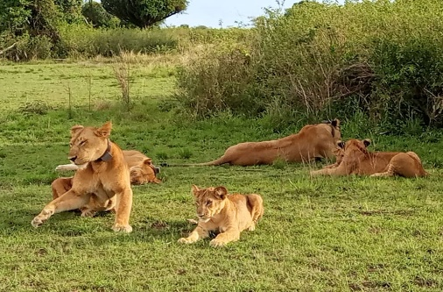

Wake up early and drive to the park approx. 430km drive. We will drive from Kampala to Masaka town with a stopover at Ugandan Equator to do the experiment and also be in 2 Hemispheres south and North at the same time. We drive via Mbarara where we will make another stop for lunch. We expect to see banana plantations, fruit markets and long horn Ankole cows among others then arrive and enter the park through

Kasenyi Gate. We check in at the lodge, dinner and overnight stay

• Accommodation: King Fisher Hotel in Queen Elizabeth National park

**DAY 3:QUEEN ELIZABETH NATIONAL PARK. (GAME DRIVE AND BOAT CRUISE**

At the park, early morning, wake up take a cup of tea and head for the thrilling game drive at 6:00am. Game to view Lion, Elephant, Leopard, Buffalo, Hyena and a variety of Antelope species. After lunch enjoy the unique 2-hour boat ride on the Kazinga Channel. You will have a chance to view Hippos on close range, have a boat cruise at kazinga chanel, watch other bird species and there after transfer back to the lodge for Dinner and overnight at

• Accommodation: King Fisher Hotel in Queen Elizabeth National park

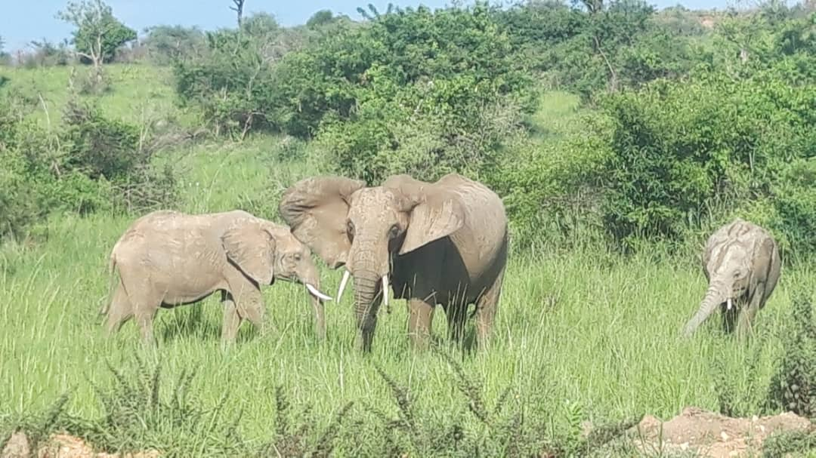

**DAY 4: DRIVE TO FORT-PORTAL CITY**

In the morning, Travel from Queen Elizabeth National Park to tourism city Fort- Portal, taking a scenic drive through the crater lakes region upon arrival in Fort Portal we do a city tour and retire to our hotel for dinner and accommodation.

• Accommodation: Mountains of the moon hotel

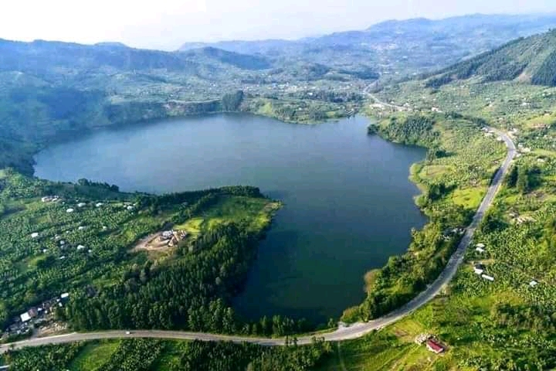

**DAY 5: MURCHISON FALLS NATIONAL PARK.**

Depart for Murchison Falls National Park in the north western part of Uganda and is the largest park with an area of 3840sqKM. It will take approximately 9-10 hours on road having a stopover at Lake Albert to view the Albertine Rift Valley from there we continue to Bugungu Gate we enter the pay may see animals on our way to the lodge like Buffalos, Lions, Giraffes,Kobs and many more. We check in at the lodge, dinner and overnight stay.

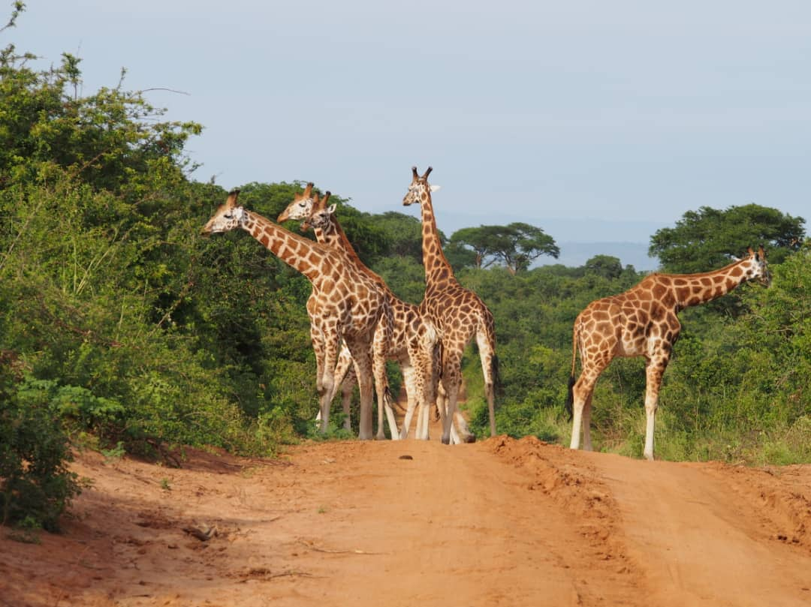 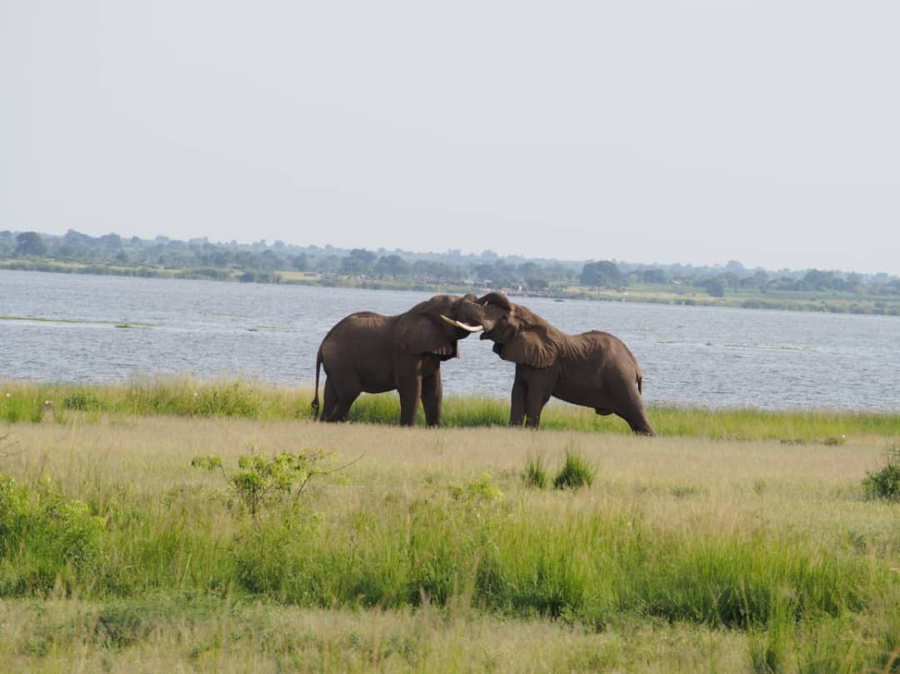

 Accommodation: Pakuba Safari Lodge

**DAY 6: MURCHISON FALLS NATIONAL PARK (GAME DRIVE AND NILE CRUISE)**

Early morning wakeup calls with packed breakfast we, go for the interesting game drive where you may see many animals such as Elephants, Buffalo, Giraffe, Lions, Uganda Kobs and many others if we lucky we can get chance of spotting world‘s rarest shoebill stork at down side of the stream during our game drive after that we break off for lunch. After lunch we go for the amazing enjoyable Nile cruise to the bottom of the mighty falls may spot animals like Hippo, Crocodiles populations/schools, and other animals alongside the river drinking water, the boat will spot at the actual point where you can clearly see the mighty Nile squeezes into 7-meter gorge for photo shorts. Thereafter, we retire at the lodge for dinner and overnight stay.

Accommodation: Pakuba Safari Lodge

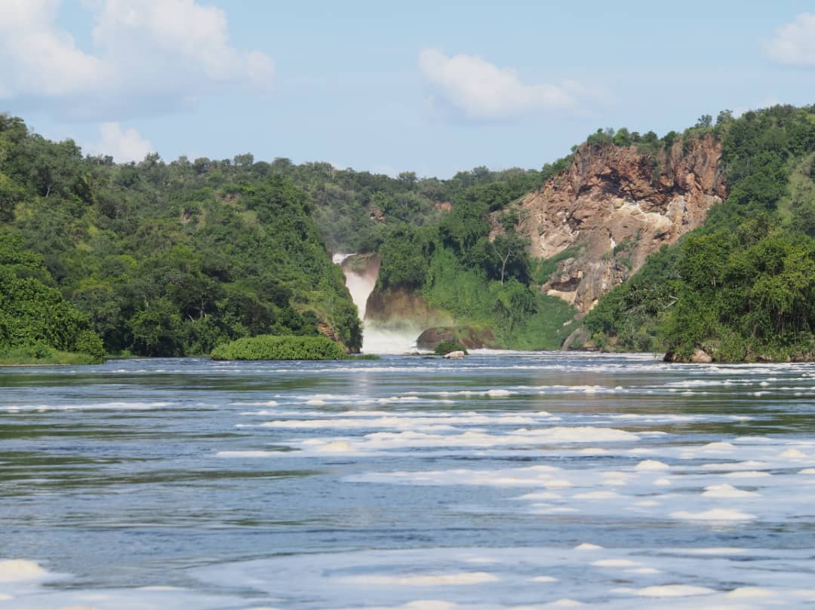

**DAY 7: DRIVE FROM MURCHISION FALLS TO LIRA**

Drive to Lira through the country side.We take breakfast then drive to Lira passing through grass

Thatched houses (Manyatta) to our hotel Margarita Place Lira and check in. There after we shall have evening City tour of Lira and back to our Hotel.

Accommodation: Margarita Place Lira

**DAY 8: DRIVE TO SOROTI.**

We leave the hotel after breakfast and drive to Soroti town upon arrival we check-in at our hotel Timisha and thereafter we do evening city tour after. Will have a chance to see the Soroti central market, visit to old houses of Indians and offices as we are taking pictures.

Accommodation: Hotel Timisha

**DAY 9: DRIVE TO MBALE.**

In the morning we leave Soroti to Mbale Town passing via popular Sipi Falls,then we continue to Mbale Town, Again we shall do a city tour after checking in at our Hotel, Mbale is the type of town which many may pass on their way to the other parts of Uganda, but it’s low-rise

Buildings and bustling streets provide a glimpse into local daily life. Markets here overflow with organic food and handmade items, and restaurants provide traditional meals.

Accommodation: Mbale Resort Hotel

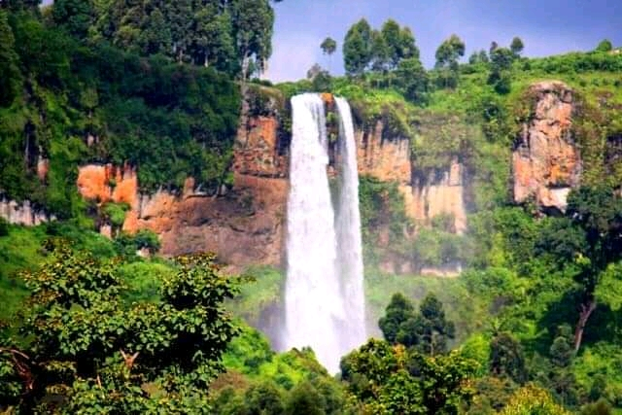

**DAY 10: VISIT TORORO ON THE WAY TO JINJA.**

After our breakfast we leave for Jinja town but via Tororo a city well known for mammoth rock formation And historical houses that belonged to tea plantation owners as well as the Hindu temples,we shall do a short city tour then we continue to and pass through Bugiri and Iganga Towns on our way to Jinja the adventure city. On arrival in Jinja, we check in at king fisher hotel after which we do a city tour and back to the hotel for dinner and rest.

**Accommodation: king fisher hotel**

**DAY 11:JINJA (NILE CRUISE TO THE SOURCE OF THE NILE)**

With a worm wake up in the Adventure city (Jinja), we take breakfast then slope down to catch our boat for a Nile cruise to the source of River Nile at this point we shall differentiate by our eyes the Lake water and River water, still from here that where River Nile starts its long journey to Mediterean Sea, we shall see the monument of Guaterm Gandie then we go for Jinja city Tour finally we retire at our Hotel, transfer back to Kampala the next day.

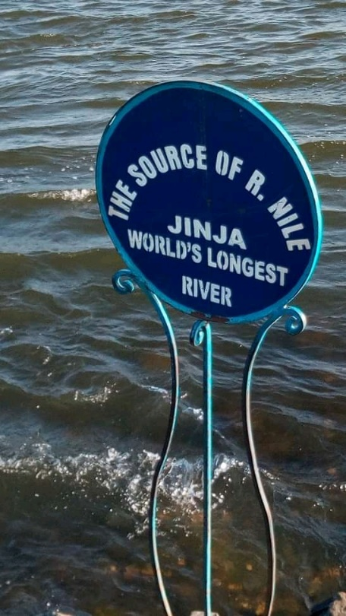

Accommodation: Kingfisher hotel.

**DAY 12: DEPARTURE BACK TO KAMPALA.**

After breakfast drive to the central part of Uganda passing through Mabira Forest which is the largest tropical rain forest in East Africa,

Arrive at Kampala and check in to Speke hotel have lunch then do a city tour in the evening around the shopping malls.

Accommodation: Speke hotel..

**DAY 13: NGAMBA ISLAND**

After breakfast we heat the road to Entebbe, we arrive at Lake Victoria Shores and get our Boat to Ngamba Island to see Orphaned Chimpanzee, we shall feed and intellect with them since the have 98.5 human DNA, and get to enjoy also the beautiful forest setting while enjoying the fresh water breeze. After we transfer back to Kampala for city Tour and retire at our Hotel

Accommodation: Speke hotel.

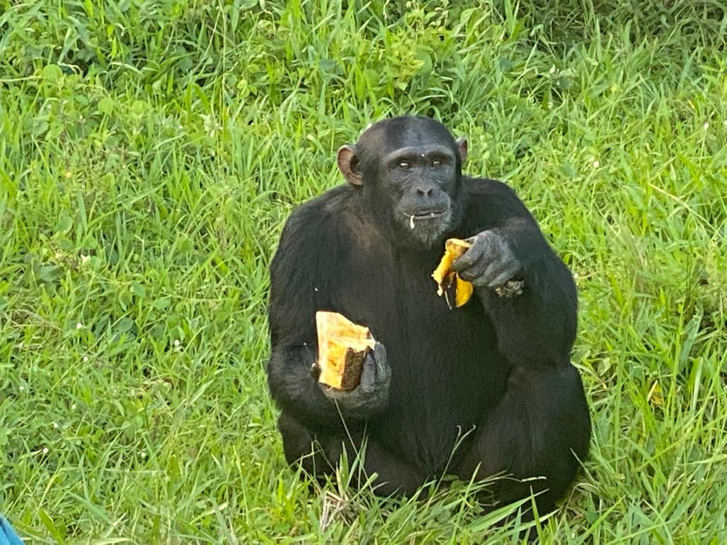

**DAY 14: KAMPALA (PCR, TEST AND SHOPPING.)**

Morning we do PCR Test the we may go for our finally city tour to the neighboring suburbs of town

Visiting the places like the national theater, craft markets

Accommodation: Speke hotel.

**DAY 15: TRANSFER TO THE AIRPORT FOR THE FLIGHT BACK HOME.**

Depending on time of our flight, we say bye to the **Pearl of Africa name by Churchill** and a country **Gifted by Nature** known by man, carrying only **beautiful memories of Uganda.**

**Note:**

**We shall arrange Indian Cuisines in Kampala and Jinja since we have more time in those cities**

**For your trip to Uganda, among others you may need to carry water bottle, Camera gear, valuables, Mosquito Repellant, Vaseline or lotion for climate changes and personal items.**

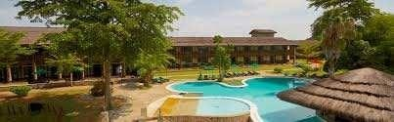

# FRIENDS NATURE SAFARIS

**P.O BOX 33725 Kampala-Uganda**

**+256-774 794383, +256-702 827550**

friendsnaturesafaris@gmail.com